ASSIGNMENT BRIEF
QUALIFICATION |  | UNIT NUMBER AND TITLE
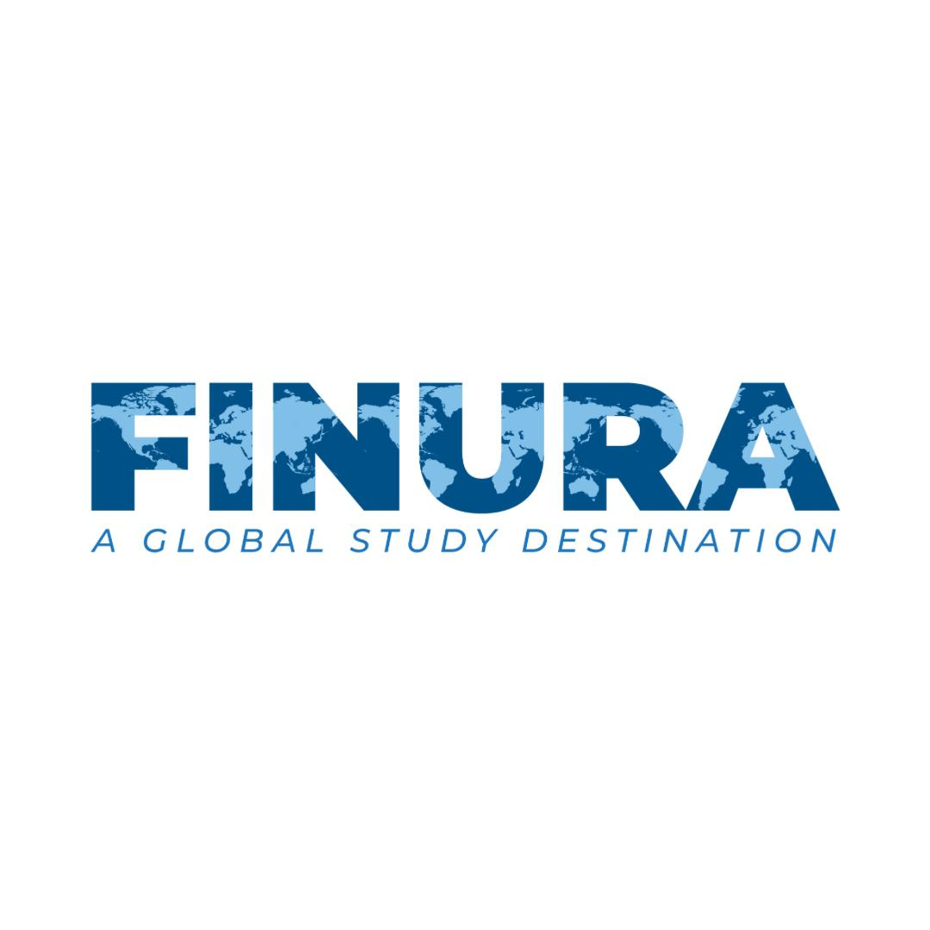  Pearson BTEC International Level 3 Qualifications in Business |  | Unit 1: Exploring Business (International BTEC LEVEL 3)
INTERNAL VERIFIER |  | ASSESSOR
 |  | AWEZA NABEEL
DATE ISSUED | SUBMISSION DATE |  | RESUBMISSION DATE
4th October 2024 | 13th October 2024

LEARNING OUTCOME AND ASSESSMENT CRITERIA
PASS | MERIT | DISTINCTION
A Explore the features of different business organizations and what makes them successful |  | AB.D1  Evaluate the reasons for the success of two contrasting business organizations, reflecting on evidence gathered.  C.D2  Evaluate the extent to which the business environment affects a given business, using a variety of situational analysis techniques.
A.P1 Explain the features of two contrasting business organizations  A.P2 Explain how two contrasting business organizations are influenced by stakeholders. | A.M1 Assess the relationship and communication with stakeholders of two contrasting business organizations using independent research.
B Investigate how businesses are organized
B.P3 Explore the organization structures, aims and objectives of two contrasting business organizations. | B.M2 Analyze how the structures of two contrasting business organizations allow each to achieve its aims and objectives
C Examine the environment in which business organizations operate
C.P4 Discuss the internal, external and competitive environment on a given business.  C.P5 Select a variety of techniques to undertake a situational analysis of a given business. | C.M3 Assess the effects of the business environment on a given business
Outcomes for submission
Learners must complete this set assignment on a computer using word processing and presentation software.
Learners must save their work regularly and ensure that all materials can be identified as their work.
Learners must submit their own, independent work as detailed in the set assignment. Each learner must complete an authentication sheet.

SUBMISSION FORMAT
THE SUBMISSION IS IN THE FORM OF TWO WRITTEN REPORTS.

THE REPORTS SHOULD BE WRITTEN IN A CONCISE, FORMAL BUSINESS STYLE USING SINGLE SPACING AND FONT STYLE CALIBRI AND SIZE 12. YOU ARE REQUIRED TO MAKE USE OF HEADINGS, PARAGRAPHS AND SUBSECTIONS AS APPROPRIATE, AND ALL WORK MUST BE SUPPORTED WITH RESEARCH AND REFERENCED USING THE HARVARD REFERENCING SYSTEM. PLEASE ALSO PROVIDE A BIBLIOGRAPHY USING THE HARVARD REFERENCING SYSTEM.PLAGIRISM WILL BE PENALIZED AND IS NEVER ACCEPTABLE.

ASSIGNMENT INSTRUCTIONS
Read the Set Assignment Information and Set Assignment carefully.

You will be asked to carry out specific activities using the information provided. You will be given a specific time period to complete the assignment.

At all times you must work independently and must not share your work with other learners. You must complete an authentication sheet and submit this along with your work.

The report should be word processed and in size 12 point font. Reference all sources of information.

The presentation must also include detailed speaker notes/script. The presentation should show your understanding of learning aim targeted. This learning aim should be prepared on presentation software.

ASSIGNMENT SCENARIO AND GUIDANCE
Your task is to write a formal business report to analyze the business environment of the two given contrasting organizations.

Save the Children UK is an international charity which works in over 60 countries around the world, including the UK. They deal with many issues which affect children, including child protection, health, education and children’s rights. Money raised by Save the Children goes to appeals in countries such as Indonesia, Yemen and Syria to help children, both at risk of conflict and natural disasters, to ease suffering and to help them to recover.

Walmart is the world's largest company by revenue, according to the Fortune Global 500 list in October 2022.^{[15]} In February 2023, Walmart announced that its FY2023 total revenue was $611.3 billion.^{[16]} Walmart is also the largest private employer in the world with 2.1 million employees. It is a publicly traded family-owned business, as the company is controlled by the Walton family. Sam Walton's heirs own over 50 percent of Walmart through both their holding company Walton Enterprises and their individual holdings.^{[17]} Walmart was the largest United States grocery retailer in 2019, and 65 percent of Walmart's US$510.329 billion sales came from U.S. operations.

TASK 1 (LO A & B) (A.P1, A.P2, B.P3, A.M1, B.M2, AB.D1)
For task 1 your analysis should be based on the two contrasting organizations mentioned above in the scenario.

Explain the features of the two contrasting business organizations i.e. Save the Children and Walmart and explain what makes them successful.
Start by giving a brief introduction of both organisations. Save the Children (non-profit) and Walmart (for profit) and answer the following:
- purpose of both businesses
- sector of operation
- type of business
- scope of activities
- key stakeholders
- extent of owner’s liability for debts
Give a detailed analysis of different stakeholders who can influence the purpose of Save the Children and Walmart. Stakeholders must include
- employees
- customers
- suppliers
- owners
- investors
- government
- local and national communities
Investigate methods of communication with stakeholders such as written, verbal etc. used by both organizations. Research each method of communication and detail the circumstances under which a business could use these methods to communicate to stakeholders.
Assess the relationship and communication with stakeholders of two contrasting business organizations using independent research.

Explore the organization structures, aims and objectives of two contrasting business organizations.
Investigate how both businesses are organized by answering the following:
Explain how these two businesses are organized. Describe the organizational structure of both the organizations, functions of their departments and how their structures enable achievement of their aims and objectives and the relationship with stakeholders.
Analyze how the structures of two contrasting business organizations allow each to achieve its aims and objectives.

Explain how business can set SMART objectives and write at least two SMART objectives for businesses in both sectors.

Evaluate the reasons for the success of Save the Children and Walmart, reflecting on the research done.

TASK 2 ( LO: C ) (C.P4, C.P5, C.M3, C.D2)

Choose any one large organization from the options given below and examine the effects of the internal and external environment as well as the competitive environment. Also, examine the risks associated with innovation and a situational analysis on the selected business organization and explain how the business has, and will, respond to changes by answering the following:
YOU ARE REQUIRED TO SELECT AN ORGANISATION FROM THE FOLLOWING LIST.
1) McDonalds
2) Nike
3) Tesla
4) Google

Discuss the internal, external and competitive environment on the selected business.
Examine the internal factors affecting on the selected organization, also discuss the external environment of the selected organization by considering impact different external environment factors. Consider how these factors could impact on a business’s objectives over a given time period. How might the external environment factors and the business’s objectives have changed over a period of time?
Introduce the environments in which businesses operate, including the political, economic, social, technological, environmental and legal environments. You should also cover the competitive environment, looking at competition from rival businesses. Explain why managers of the selected organizations needs to understand the capabilities of their business and the needs of their customers, as well as the business environment in which they operate.
Explain business laws that have been created to protect businesses, employers, employees and consumers.

Select a variety of techniques to undertake a situational analysis of a given business.
Outline the process and types of situational analysis and apply the models on the selected organizations, such as
PESTLE,
SWOT,
5Cs
And Porter’s five Forces,
And look at how important they are in providing vital insight into the business environment.
Assess the effects of the business environment on the chosen business.

Evaluate the extent to which the business environment affects the selected business, using a variety of situational analysis techniques.

EVIDENCE CHECKLIST | SUMMARY OF EVIDENCE REQUIRED BY STUDENT
TASK 1 | Report
TASK 2 | Report

